

**MobiTel**

**User Guide**

For Android Operating System

Contents

[1. Getting Started 1](#_Toc370660155)

[1.1 MobiTel Icons 1](#_Toc370660156)

[1.2 Login 3](#_Toc370660157)

[1.3 Change Language 3](#_Toc370660158)

[1.4 Logout 4](#_Toc370660159)

[2 Using the MobiTel App 4](#_Toc370660160)

[2.1 Managing your Business 4](#_Toc370660161)

[2.1.1 Add Business 5](#_Toc370660162)

[2.1.2 View Business Details 7](#_Toc370660163)

[2.1.3 Edit Business 8](#_Toc370660164)

[2.1.4 Remove Business 8](#_Toc370660165)

[2.2 Managing Accommodations 10](#_Toc370660166)

[2.2.1 Add Accommodation 11](#_Toc370660167)

[2.2.2 View Accommodation Details 13](#_Toc370660168)

[2.2.3 Edit Accommodation 14](#_Toc370660169)

[2.2.4 Remove Accommodation 15](#_Toc370660170)

[2.3 Manage Room 16](#_Toc370660171)

[2.3.1 Add Room 17](#_Toc370660172)

[2.3.2 View Room Details 19](#_Toc370660173)

[2.3.3 Edit Room 20](#_Toc370660174)

[2.3.4 Remove Room 20](#_Toc370660175)

[3 Synchronisation 22](#_Toc370660176)

[3.1 How to sync 22](#_Toc370660177)

# Getting Started

## MobiTel Icons

Each of the icons below executes a particular action when the business owner selects them:

|  |  |  |
| --- | --- | --- |
| MobiTel Icon |  | Action |
| C:\Users\g09m3478\Dropbox\Honours SysDev\Luminus Solutions Final Documentation\Design\App_icon.png | *MobiTel App* | Opens the MobiTel app from the Android device. |
|  | *Home* | Directs user back to the Home Screen. |
|  | *Sync* | Synchronises Business, Accommodation and Room details with TeleWeaver. |
|  | *Add* | Business, Accommodation and Room details can be added onto the app. |
|  | *Edit* | Business, Accommodation and Room details can be edited on the app. |
|  | *Remove* | Business, Accommodation and Room details can be removed/deleted from the app. |
|  | *Save* | Changes made on the app will be saved on the mobile device for synchronisation. |
|  | *Cancel* | Changes made on the app can be cancelled. |
|  | *Gallery* | A list of images saved on the mobile device can be viewed for selection. |
|  | *Accommodation Gallery* | A list of images saved on the MobiTel app for Accommodations. |
|  | *Capture* | Allows the user to capture an image. The image is stored in the gallery. |
|  | *New Image* | A new image can be selected. |
|  | *Icon Bar* | A list of icons is available for selection. |

**Table 1. MobiTel Icons**

## Login

When you open the MobiTel App, you will be presented with a **login** screen. In order to start using the MobiTel application, you need to login to the app. Place the cursor on the “**Enter username**” field and enter your username as assigned to you by Reed House Systems for Teleweaver.

Once you have entered your username, place your cursor on the “**Enter Password**” field and enter your password for Teleweaver as assigned to you by Reed House Systems. Once you have entered your password, select the “**Login**” button.

If you are using the app for the first time, you must be connected to a designated Wi-Fi network in order to confirm that your username and password are correct. Thereafter you can use the app without a Wi-Fi connection, except when you want to synchronise your information with Teleweaver.

## Change Language

To change the language on the MobiTel Application, select the “**Language”** drop-down box. This gives you the option to select between English or isiXhosa.

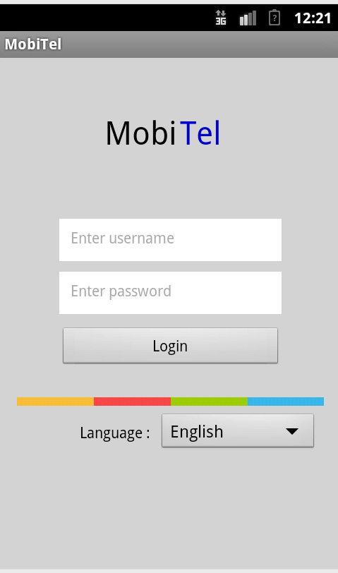

*Enter password field*

*Enter username field*

*Name of the Mobile Application*

*Login Button*

*Language drop-down box*

## Logout

To exit the application, select the ‘**Logout**’ icon. This icon is present at the top-right corner of every screen (refer to Table 1 for a list of icons).

# Using the MobiTel App

## Managing your Business

You can manage your businesses from the ‘**Businesses**’ screen, which is the first screen that appears after you have logged in to the MobiTel App.

In order to select a business, tap on a specific business from the list of businesses. This will be able you to manage that particular business by adding, updating or deleting your business details.

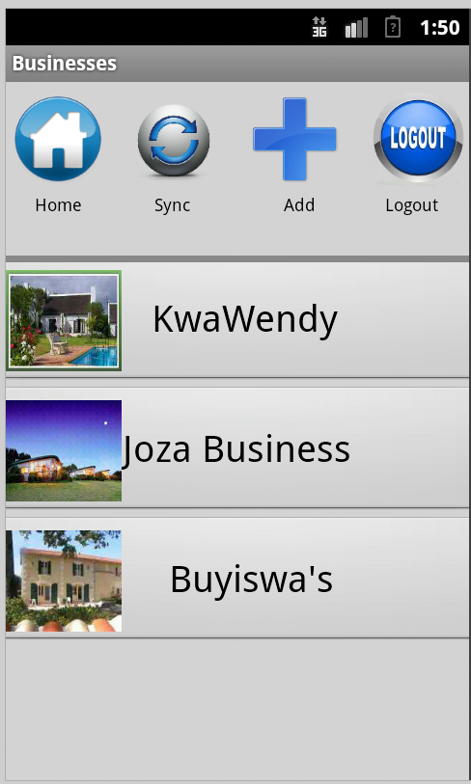

*Icon Bar*

*Business Image*

*Screen Name*

*List of Businesses*

### Add Business

You can add a new business by selecting the “**Add**” icon, which is located on the top of the screen. The ‘Add Business’ screen will then appear:

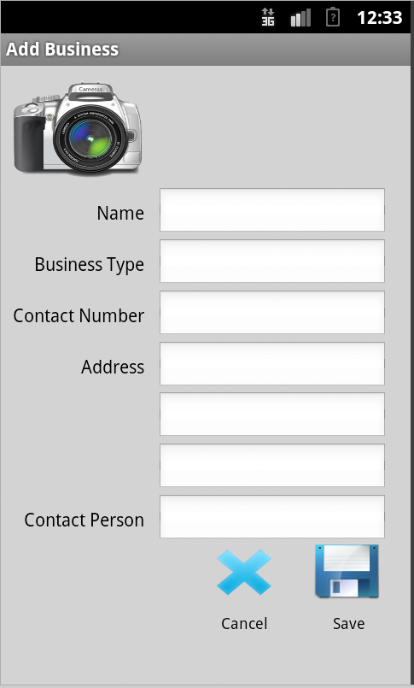

*Fields for business information*

*Camera Icon*

*Screen Name*

Place the cursor in the respective fields (Name, Business Type, Contact Number, Address, and Contact Person and enter the required information. You can add an image by selecting the ‘**Camera’** icon. You can choose to upload an image from your gallery or by taking a photo using your mobile device.

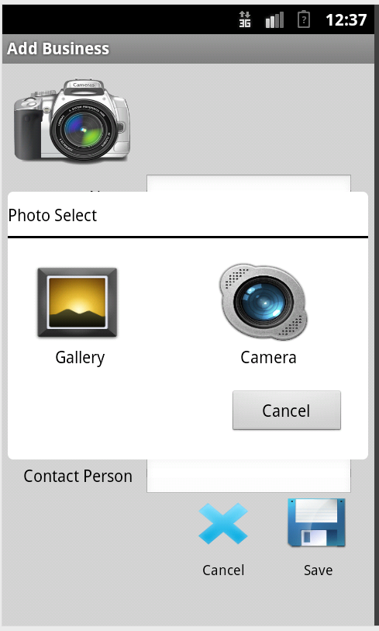

*Select an Image from the following options*

*Screen name*

Once you have entered all your business information, select the ‘**Save**’ icon. The ‘**Businesses**’ screen will then be displayed, showing the business you have entered into the app.

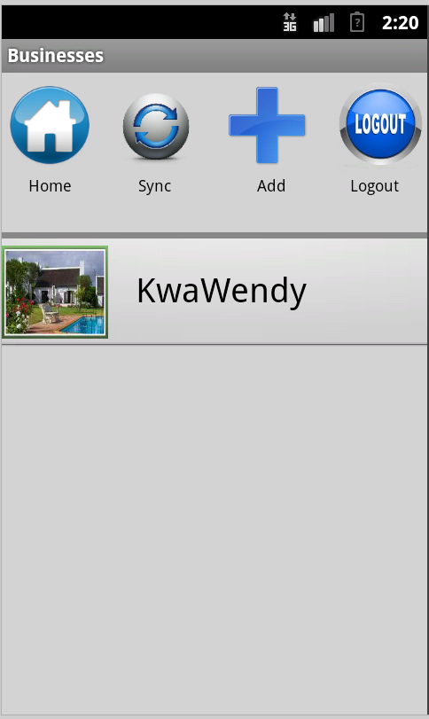

*Business name*

*Business Image*

### View Business Details

To view the details of a business, select the business that you would like to view on the ‘Businesses’ screen. You can do this by selecting the business name or business image.



*Business Name*

*Business Image*

The ‘**Business Details**’ screen will then be displayed with the details of the business that you previously selected.

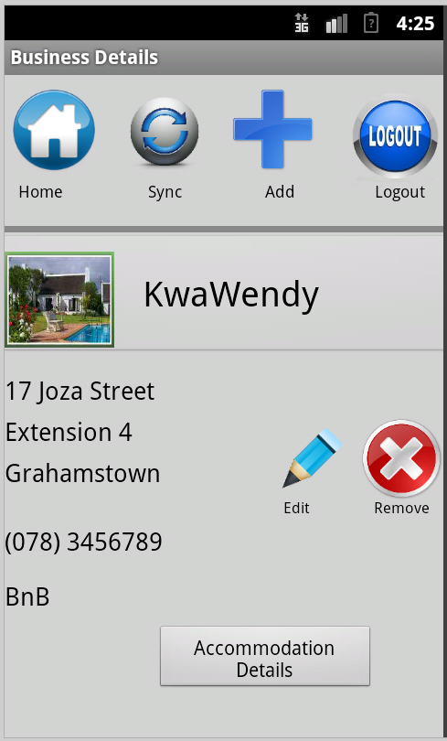

*Details of the business*

### Edit Business

You can edit your business details by selecting the ‘**Edit**’ icon on the ‘**Business Details**’ screen. The ‘**Edit Business Details**’ screen will then be displayed:

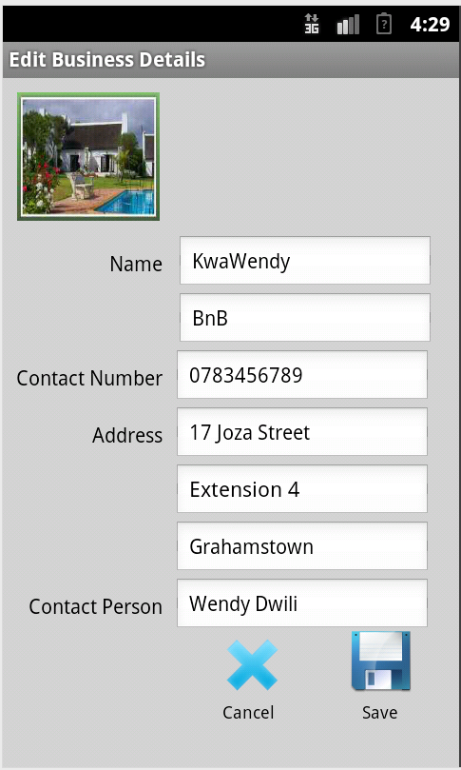

*Details of the business*

*Screen name*

Once you have edited your business details you can then select the ‘**Save**’ icon to save the changes.

### Remove Business

To remove a business from the app, select the business you want to remove on the ‘**Businesses**’ screen. The ‘**Business Details’** screen will then appear. Select the ‘**Remove**’ icon. An alert will appear enquiring whether you are sure you want to remove the business profile you have selected.

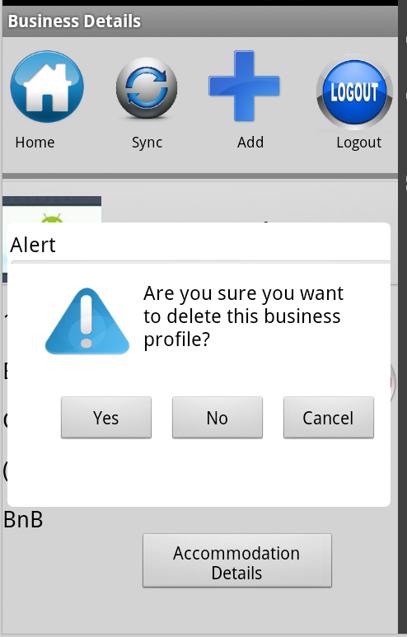

*Prompt confirming your decision to remove a selected business.*

To confirm that you want to remove the selected business, select ‘**Yes**’. If you do not want to remove the selected business, select ‘**No**’. In order to remove the dialog box select ‘**Cancel**’. Once you have selected ‘**Yes**’ to confirm that you want to remove the business, the ‘**Businesses**’ screen will appear with the removed business not visible on the screen.

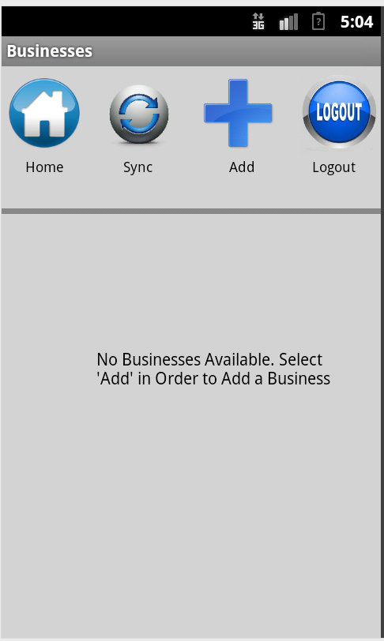

*Prompt to add a business*

### Managing Accommodations

You can manage your Accommodations from the ‘**Accommodations**’ screen. Once you have selected the accommodation from the list, you will be able to manage that particular accommodation by inserting, updating or deleting your accommodation details. An accommodation belongs to a business, so you must first select the business for which you would like to manage accommodations.

In order to manage your Accommodations, select the ‘**Accommodation Details**’ button on the ‘**Business Details**’ screen for the business you would like to manage accommodations for.



*Details of the business*

*Accommodation Details Button*

The ‘**Accommodations**’ screen will then appear.

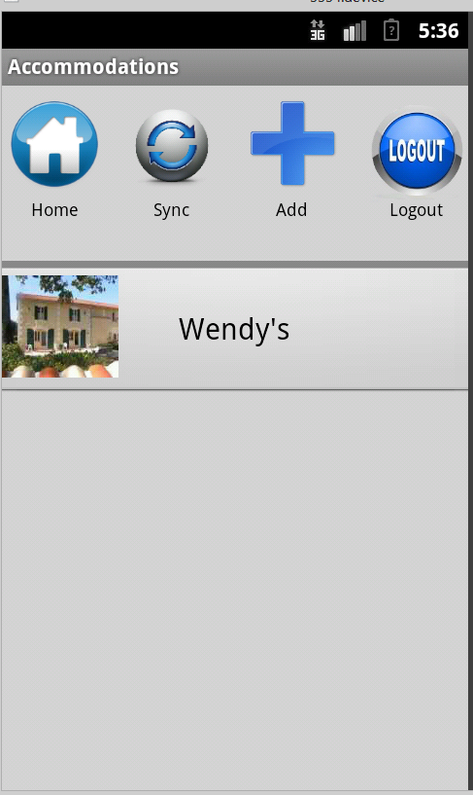

*Accommodation Name*

*Accommodation image*

### Add Accommodation

You can add a new accommodation by selecting the ‘**Add**’ icon, which is located on the top of the screen. The ‘**Add Accommodation**’ screen will then appear:

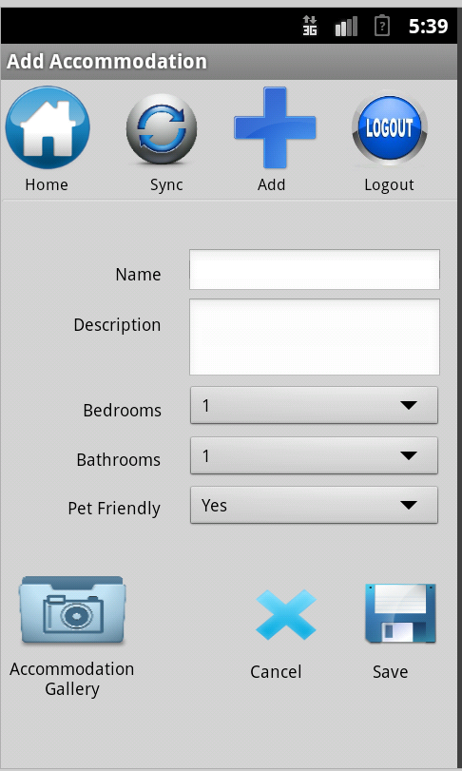

*Details of the Accommodation*

Enter your accommodation information in the relevant fields. You can add an image by selecting the ‘**Accommodation Gallery**’ icon. An ‘**Accommodation Gallery**’ dialog box will appear. You can choose to upload an image from your gallery or by taking a photo using your mobile device. To do this you would select the ‘**New Image**’ icon.

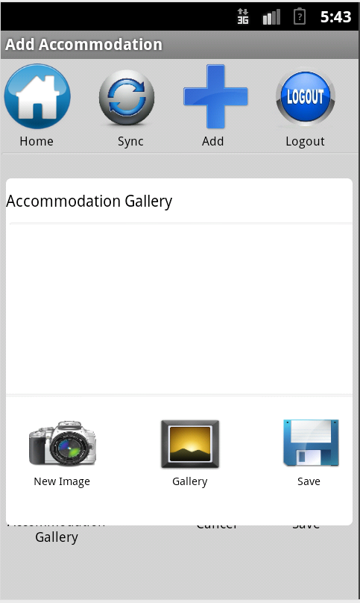

*Accommodation Gallery Dialog*

You can enter up to three images for your accommodation. Once you have entered the images, select the ‘**Save**’ icon. Once you have selected the ‘**Save**’ icon, the ‘**Accommodation Gallery**’ dialog will disappear, displaying the ‘**Add Accommodation**’ details screen once again.

Once you have entered all your accommodation information, select on the ‘**Save**’ icon. The ‘**Accommodations**’ screen will be displayed, showing the accommodations you have entered into the app.

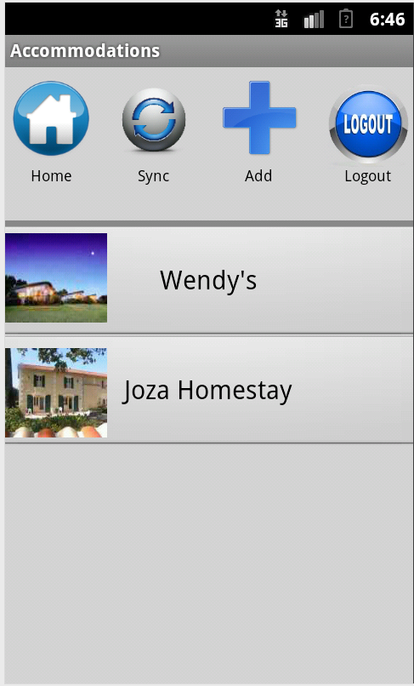

*Accommodation image*

*Screen Name*

*List of Accommodations*

### View Accommodation Details

To view the details of an accommodation you would like to view, select the accommodation on the ‘**Accommodations**’ screen. You can do this by selecting on the accommodation name or image.



*Accommodation image*

*Accommodation Name*

The ‘**Accommodation Details**’ screen will then be displayed with the details of the accommodation that you previously selected.

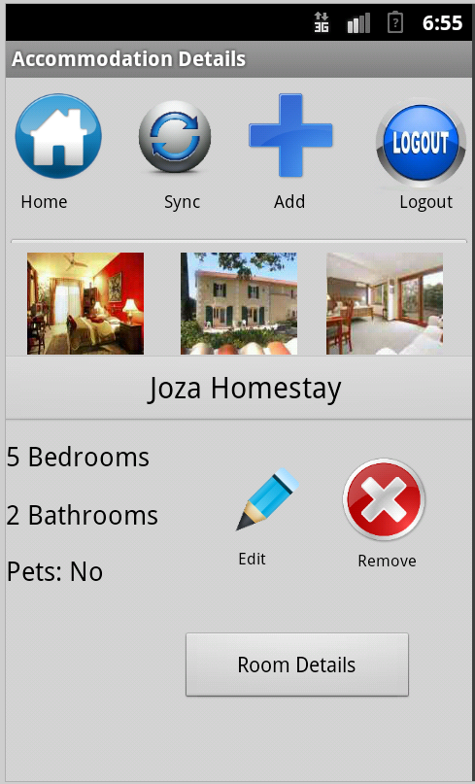

*Screen Name*

*Details of the Accommodation*

*Accommodation Name*

*Accommodation image*

### Edit Accommodation

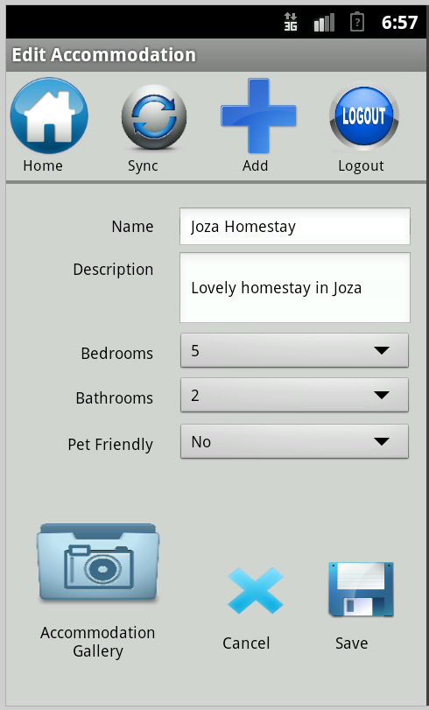You can edit your accommodation details by selecting the ‘Edit’ icon on the ‘Accommodation Details’ screen. The ‘Edit Accommodation Details’ screen will then be displayed:

*Screen Name*

*Details of the Accommodation*

Once you have edited your accommodation details you can then select the ‘**Save**’ icon to save the changes.

### Remove Accommodation

To remove an accomodation from the app, select the accommodation you want to remove on the ‘**Accommodations**’ screen. The ‘**Accommodation Details’** screen will then appear. Select the ‘**Remove**’ icon. An alert will appear requesting you to confirm whether you are sure that you want to remove the accommodation profile you have previously selected.

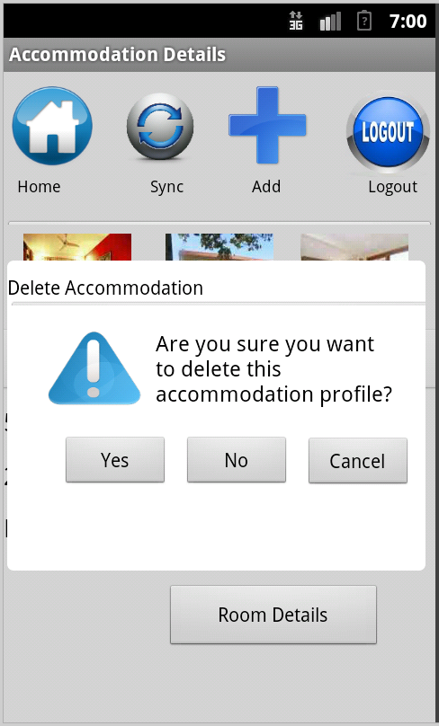

*Dialog box confirming the decision to delete an accommodation*

*Screen Name*

To confirm that you want to remove the selected accommodation, select ‘**Yes**’. If you do not want to remove the selected accommodation, select ‘**No**’.

Once you have selected ‘**Yes**’ to confirm that you want to remove the accommodation, the ‘**Accommodations**’ screen will appear with the selected accommodation not appearing on the screen.



*List of Accommodations*

### Manage Room

You can manage your Rooms from the ‘**Accommodations**’ screen. Once you have selected the accommodation from the list, you will be able to manage that particular accommodation by inserting, updating or deleting your business details.



*Room Details Button*

*Accommodation Name*

Once you have selected the ‘**Room Details’** button, the ‘**Rooms**’ screen will appear.

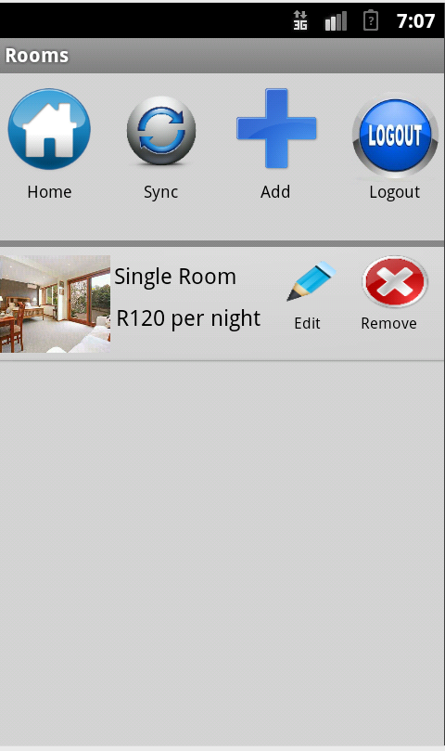

*Room image*

### Add Room

You can add a new room by selecting the ‘**Add**’ icon, which is located on the top of the screen. The ‘**Add Room’** screen will then appear:

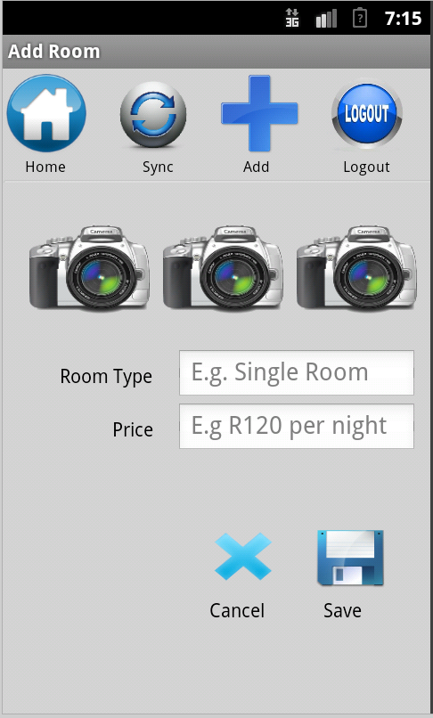

*Camera Icon*

*Details of the Room*

Enter your room information in the relevant fields. You can add an image selecting the ‘**Camera**’ icon. A ‘**Room Image’** dialog will appear. You can choose to upload an image from your gallery or by taking a photo using your mobile device.

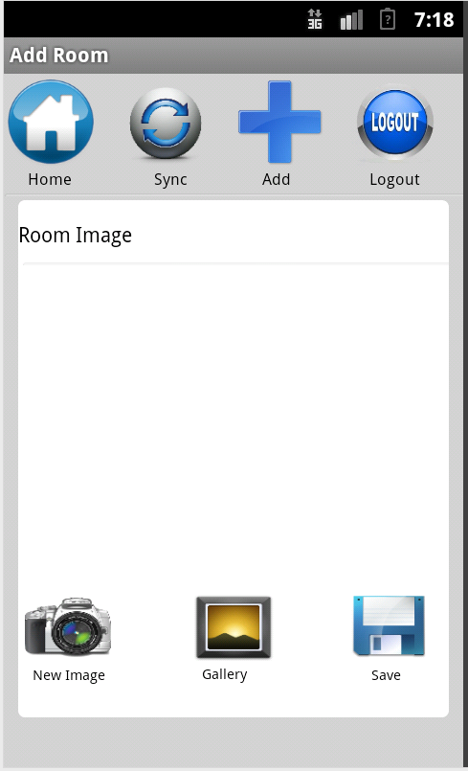

*Room Image Dialog*

You can enter up to three images for your room. Once you have entered the images, select the ‘Save’ icon. Once you have selected the ‘**Save**’ icon, the ‘**Room Image**’ dialog will disappear, displaying the ‘**Add Room**’ details screen once again.

Once you have entered all your room information, select on the ‘**Save**’ icon. The ‘**Rooms**’ screen will be displayed showing the rooms that you have entered into the app.

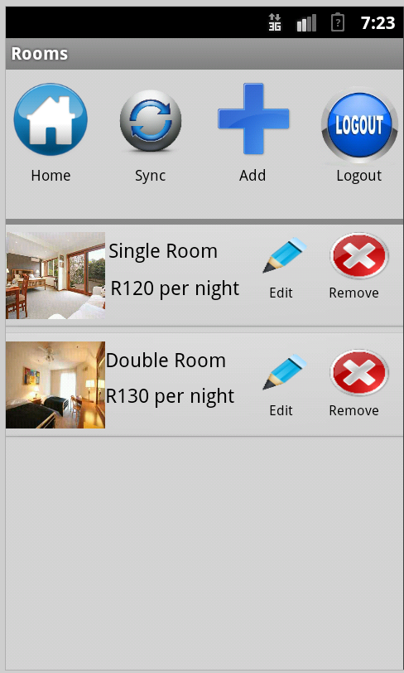

*Room image*

*List of Rooms*

### View Room Details

The details of the room are displayed on the ‘**Rooms**’ screen.



*List of Rooms*

### Edit Room

You can edit your room details by selecting the ‘**Edit**’ icon on the ‘**Rooms**’ screen. The ‘Edit Room’ screen will then be displayed:

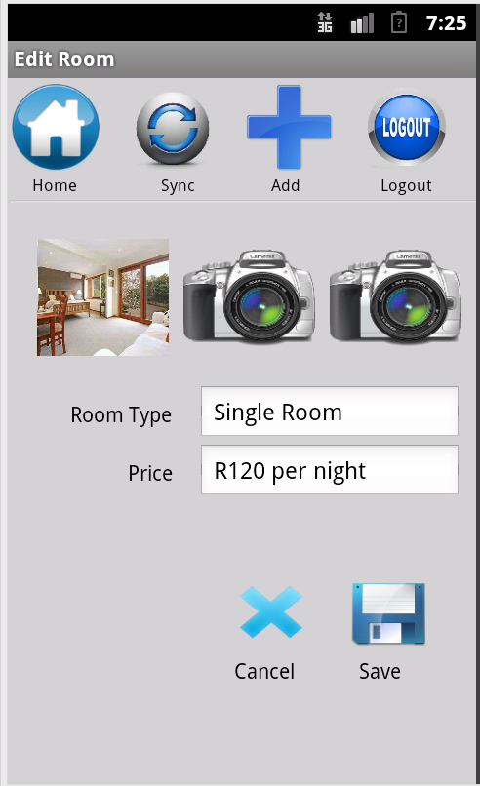

*Room image*

*Details of the Room*

Once you have edited your room details you can then select the ‘**Save**’ icon to save the changes.

### Remove Room

To remove a room from the app, select the room you want to remove on the ‘**Rooms**’ screen. The ‘**Accommodation Details**’ screen will then appear. When you select the ‘**Remove**’ icon, an alert will appear confirming whether you are sure you want to remove the accommodation profile you have selected.

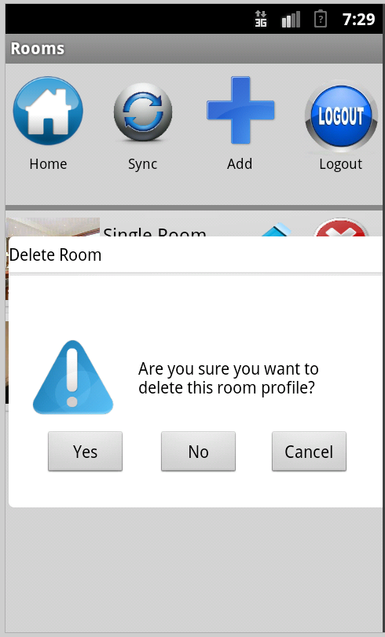

*Dialog box confirming the decision to delete a room*

To confirm that you want to want to remove the selected room, select ‘**Yes**’. If you do not want to remove the selected room, select ‘**No**’.

Once you have selected ‘**Yes**’ to confirm that you want to remove the room, the ‘**Accommodations**’ screen will appear with the selected accommodation not appearing on the screen.

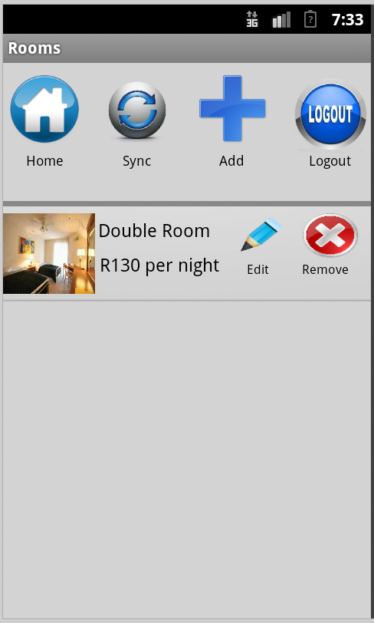

*List of Rooms*

# Synchronisation

## How to sync

In order to send your business, accommodation and room information to the Teleweaver website, you must synchronise all your information with Teleweaver. To do so, you must be connected to a designated Wi-Fi network.

To synchronise your information, select the ‘**Sync**’ icon, which can be found at the top of all the main screens on the app.

Once you select the ‘**Sync**’ icon, a dialog box will appear to alert you that all your information has been synchronised.

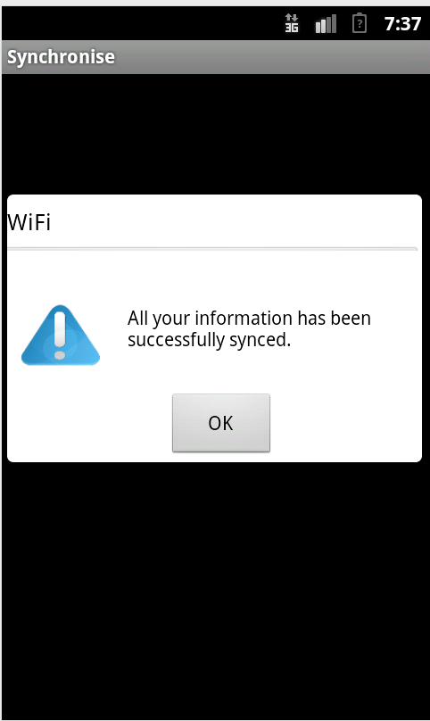

*Dialog box confirming synchronization of information*

Once you select on the OK button, the ‘**Businesses**’ screen will open. If you have already synchronised and there is no new information to synchronise on the app, a dialog will appear informing you.

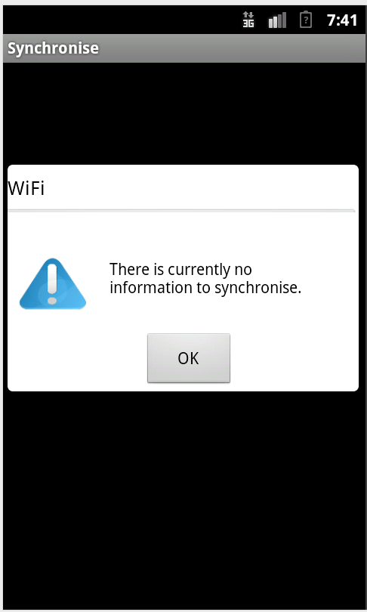

*Dialog box confirming synchronization of information*